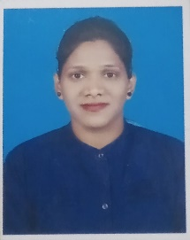
PRAVASINI NAIK
CONTACT:8455079771
Email:pravasininaik1995@gmail.com
Acharya Vihar Bhubaneswar 751022
CAREER OBJECTIVES
To build career in a growing organization, where I can get the opportunities to prove my abilities by accepting challenges, fulfilling the organizational goal and climb the career ladder through continuous learning and commitment.
ACDEMIC QUALIFICATION
- 10th passed from B.S.C Odisha in 2011.
- Diploma in ETC passed from SCET&VT Odisha 2015.
- Graduation B TECH ECE passed from BPUT Odisha 2019.
OTHER QUALIFICATION
- Basic knowledge of computer.
- CTTC in 2016 ( PLC, VLSI ).
PERSONAL SKILL
- Honesty
- Concern in my work
- Cooperative
- Patience

PERSONAL DETAILS
- Date of Birth :18/04/1995
- Father’s Name :Dhaneswar Naik
- Sex :Female
- Marital Status :unmarried
- Languages Known :Odia, English, Hindi
- Nationality :Indian
- Hobbies :Listening Music, Easy to friendly
DECLARATION
I solemnly declare that all the above information is correct to the best of my knowledge and belief.

Date
Place
Pravasini Naik

